How to Use ToonBoom Storyboard PRO
The Basics
By: Jessica Ordaz
- Upon opening the program, you’ll be greeted with this intro screen. Here, you’ll be able to name your project, choose where you want it saved, and figure out the size of the canvas, as well as the frames per second. Everything already filled in is default, which you can leave, just name your project on PROJECT NAME and choose where it will be saved in PROJECT DIRECTORY.
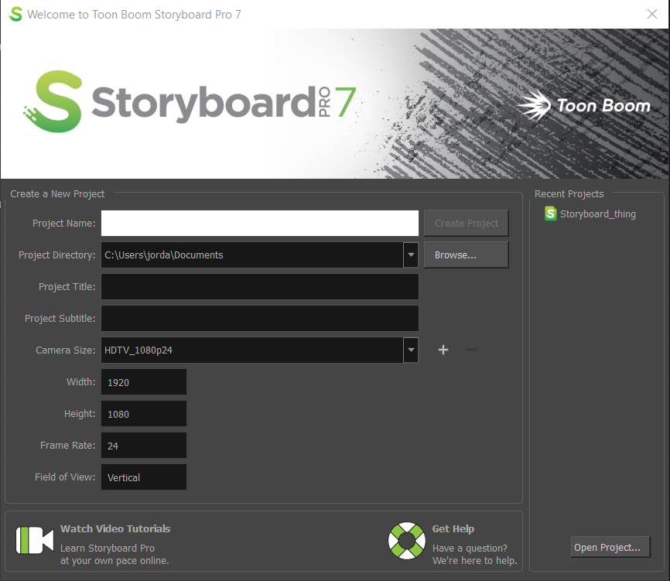

- After clicking Create Project, you’ll be shown your main canvas! To change the way this canvas looks, you can pick between these options! It will change the way all your tools are organized in front of you (Note: the little music note is the default view for ToonBoom Storyboard PRO).
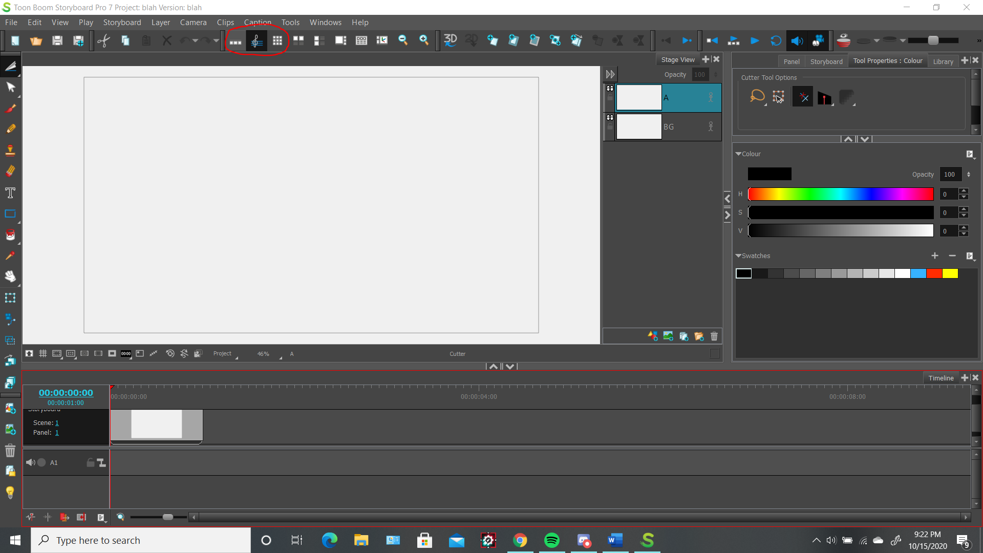
  - This section is your timeline, it will show all of the drawings you have made in all the different panels.
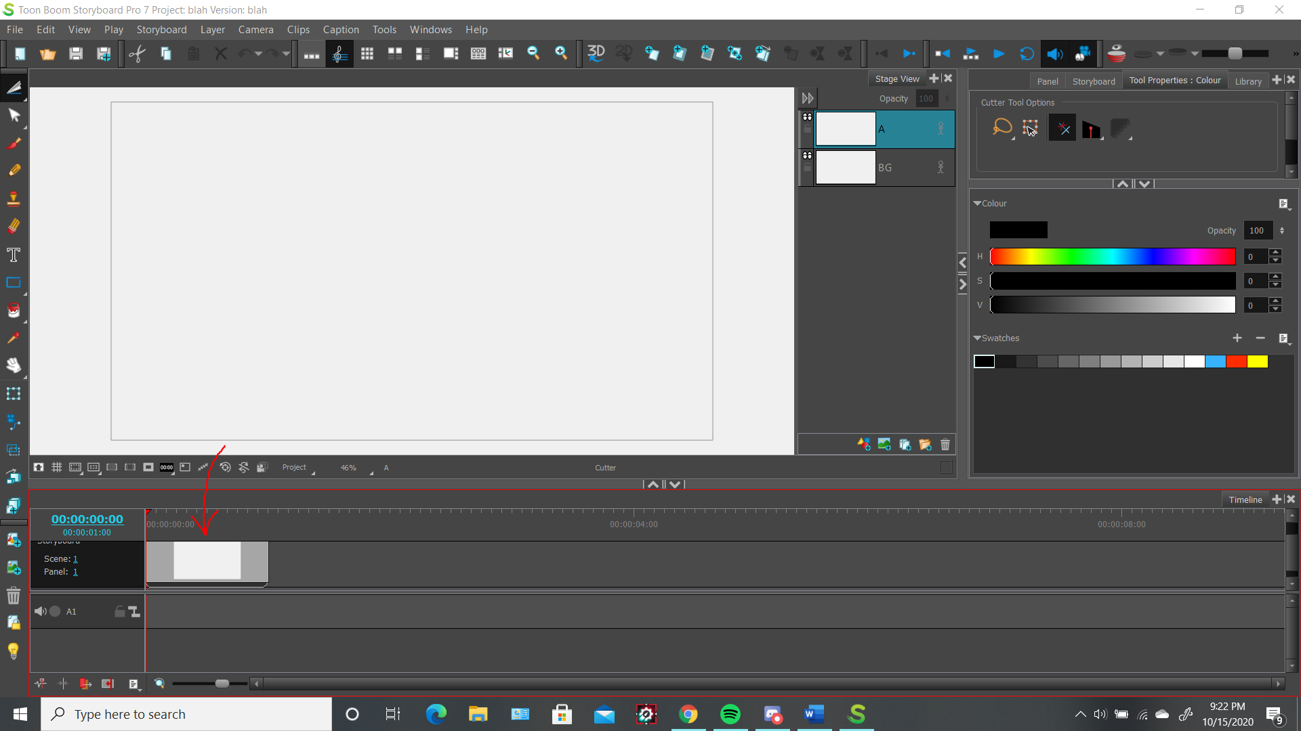
  - These tools with arrows are the tools you will be using the most. The top tool cuts out a drawing and lets you resize the drawing you selected, the paintbrush tool is to draw, your eraser tool erases whatever is on canvas, the T tool lets you put words on the canvas, and the hand tool lets you move your canvas around.
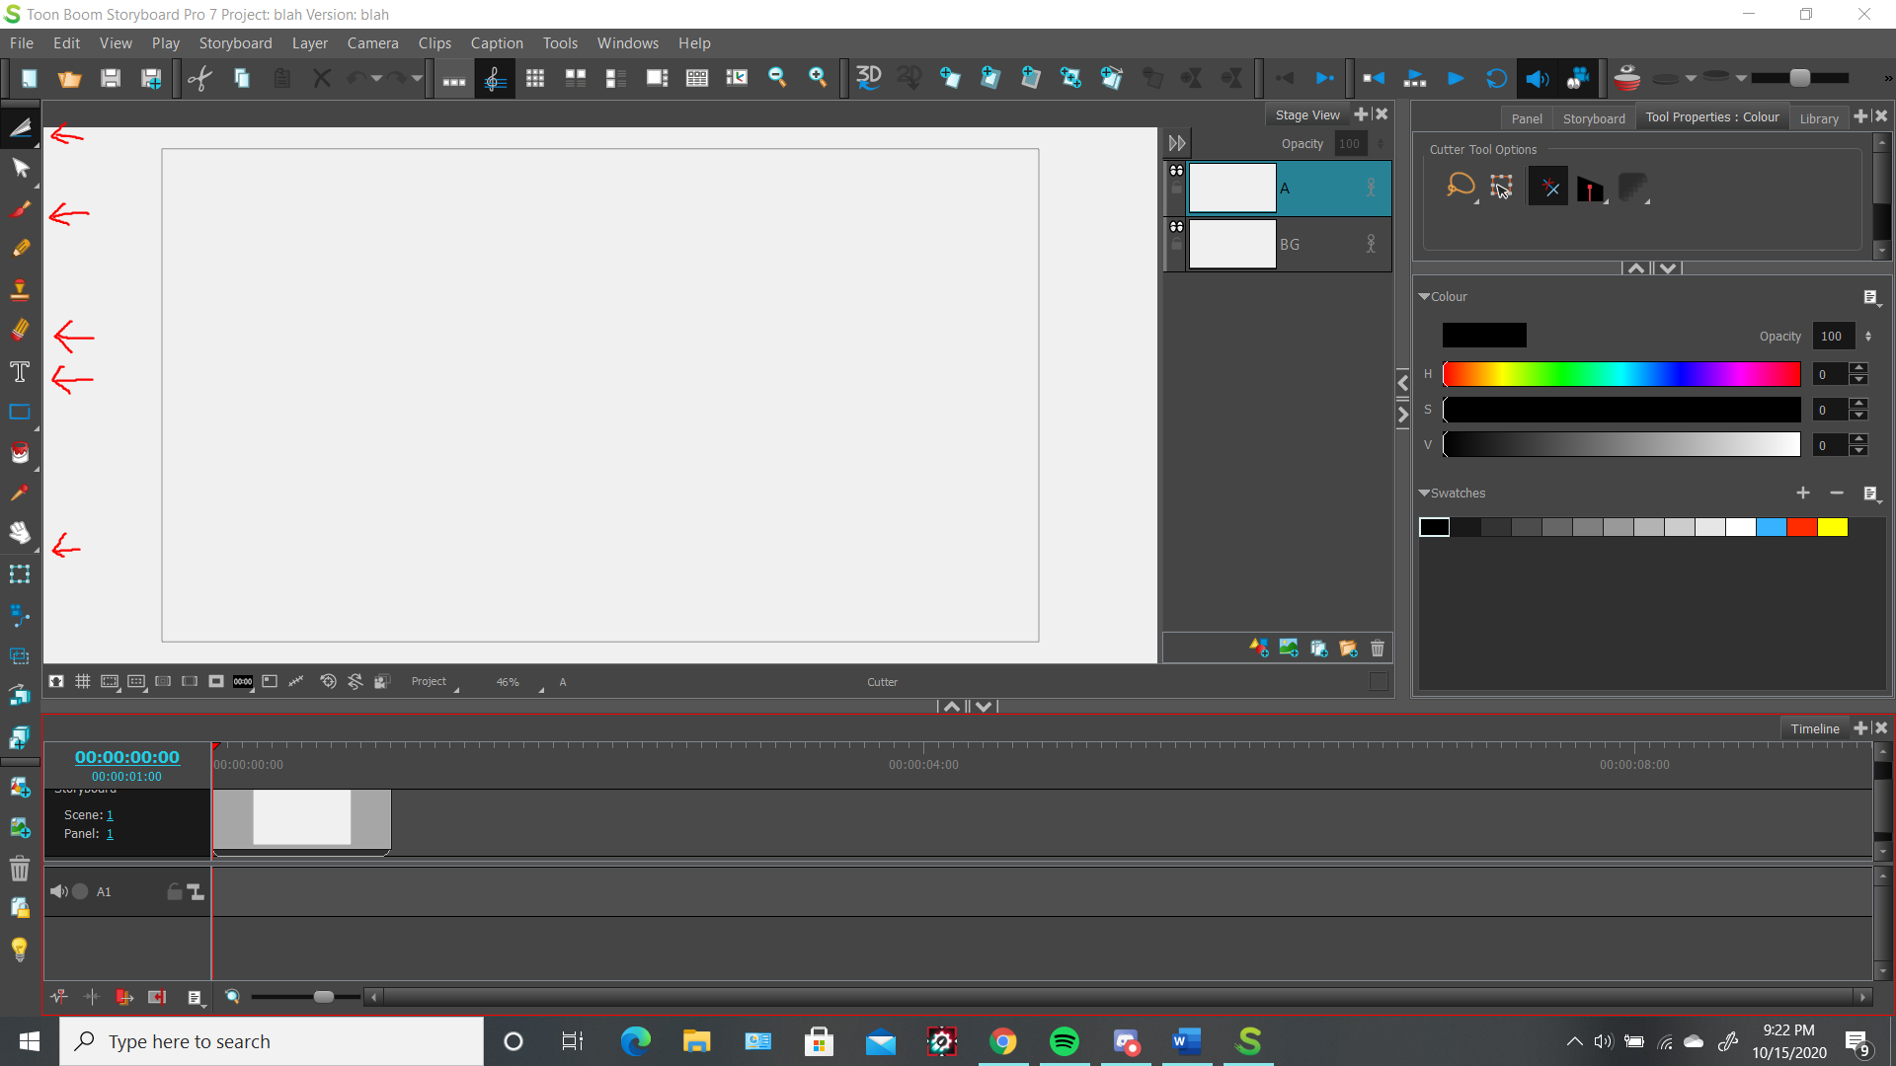
  - Every drawing has multiple layers, so you can draw over a current drawing displayed on the canvas. Here I have 3 drawings, and each are on a different layer. This button lets you add a layer.
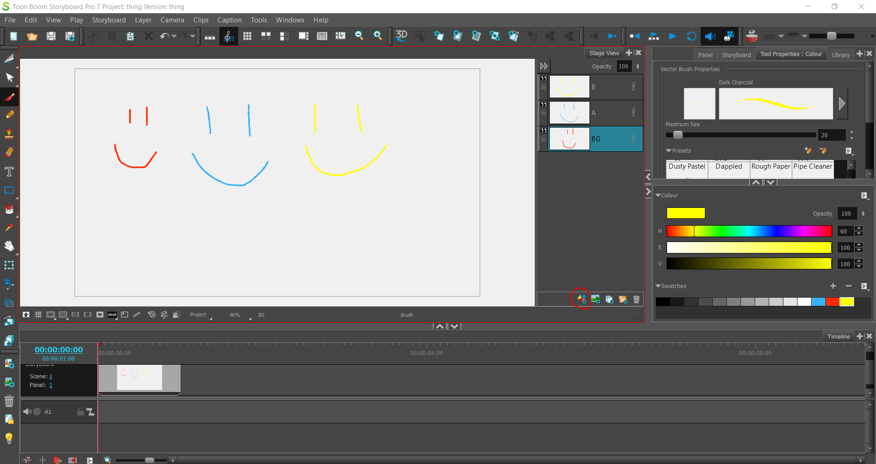
  - On the right side of the screen, you will find different kinds of brushes to draw with, including some that look like pencils and others that look like ink pens. There’s a lot of options! You can also pick the color you want and change the size of your brush here too.
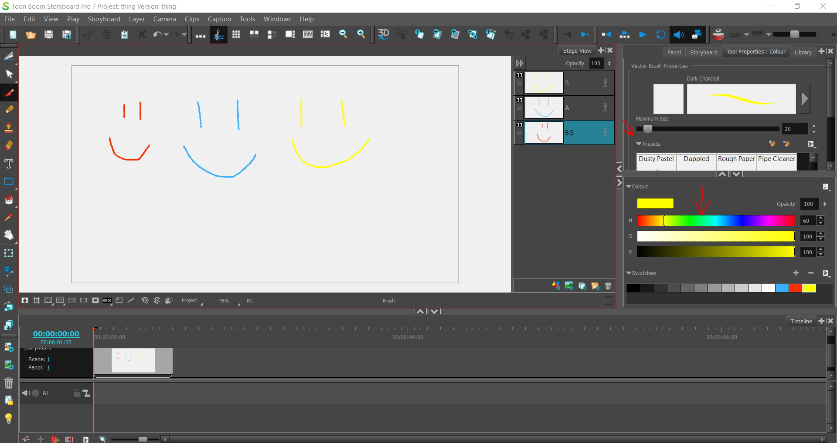
- To zoom in and out of your canvas, click this button.
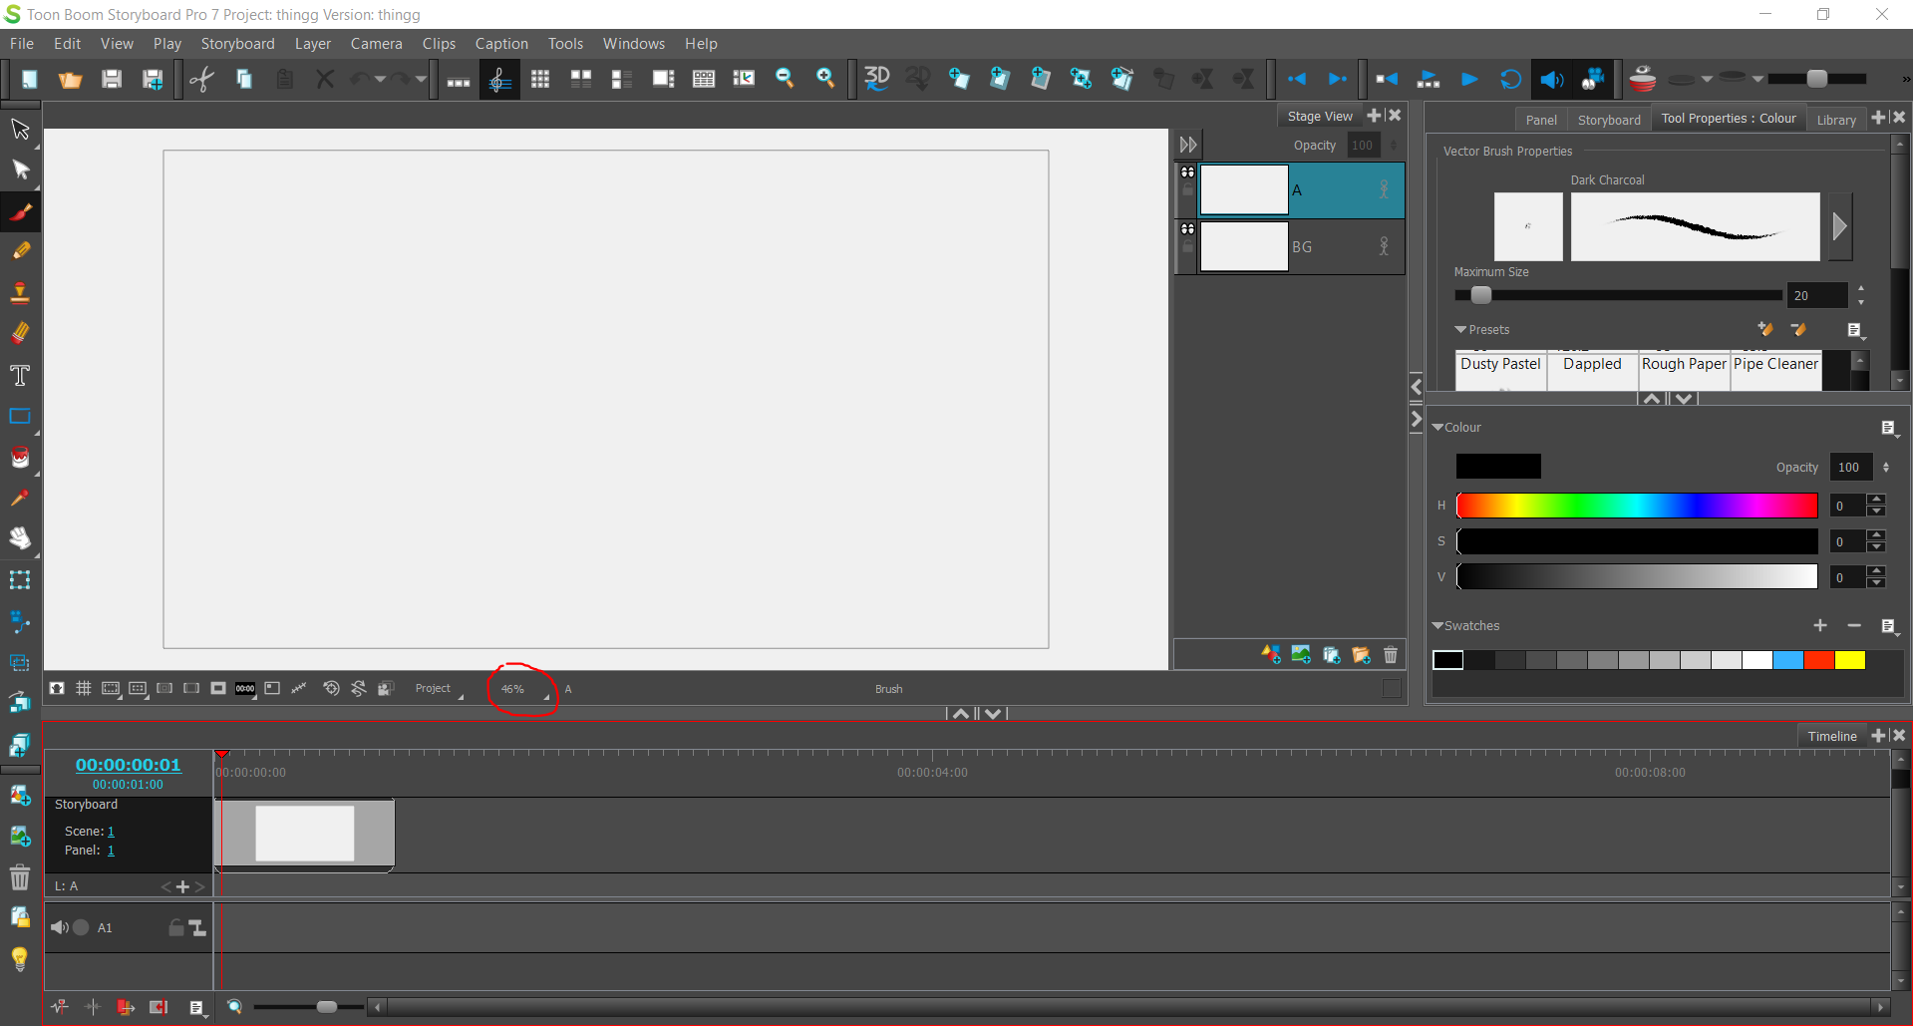

- Now let’s say you want to add panels. You can do that using this + button! Similarly, you can remove a drawing by pressing the – button.
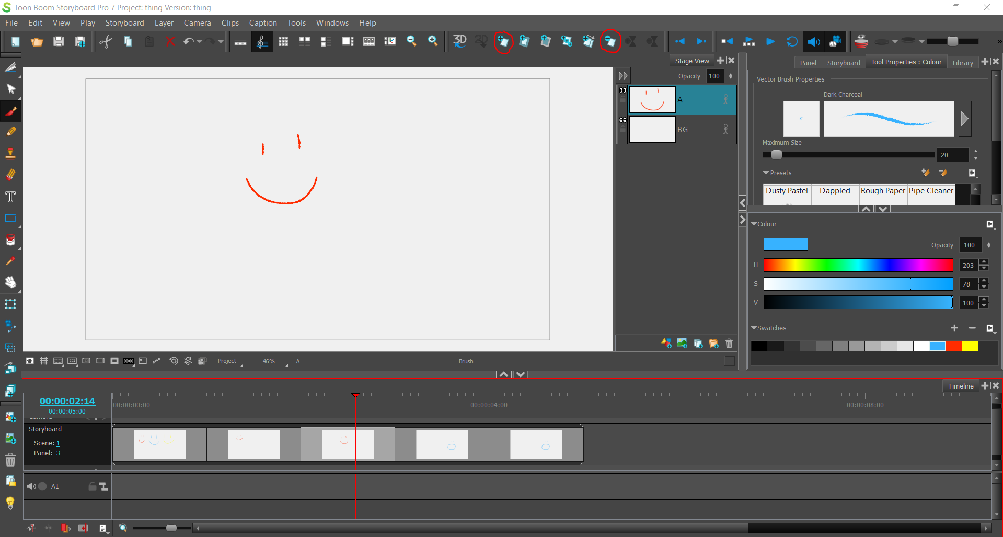
- Onion skins are important. An onion skin is a feature that allows you to see what the next panel looks like (in green) and what the previous panel looks like (in red) that you have made and drawn. You can turn onion skins on and off using this button.
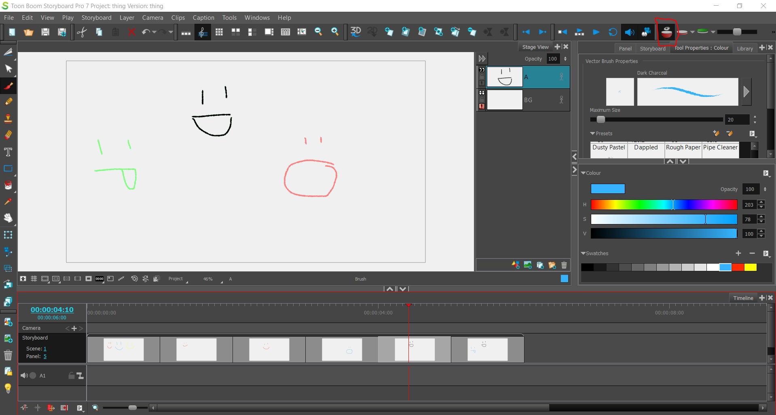

- Now let’s say you have a lot of panels! You can scroll between all the panels by dragging this button to the left and to the right.
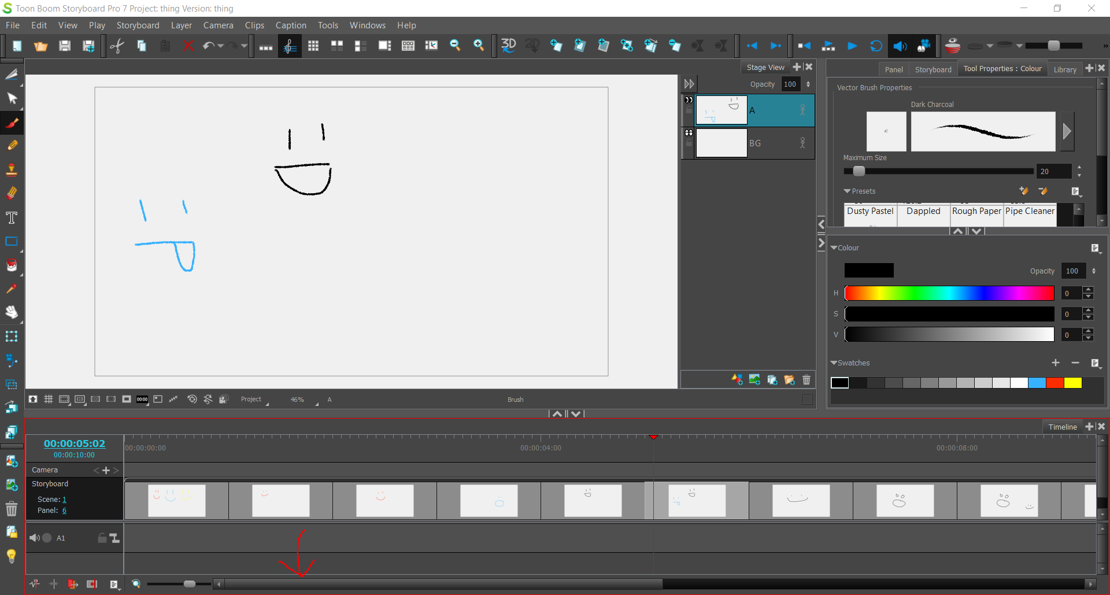

- So now, you probably are going to want to time out each panel to last a specific amount of time. To do so, you simply have to grab the edge of a panel and pull it right and left to make it shorter or longer. On the left of your screen (in blue numbers) you will see what minute/second you’re on and below the big numbers is how long your whole storyboard is so far.
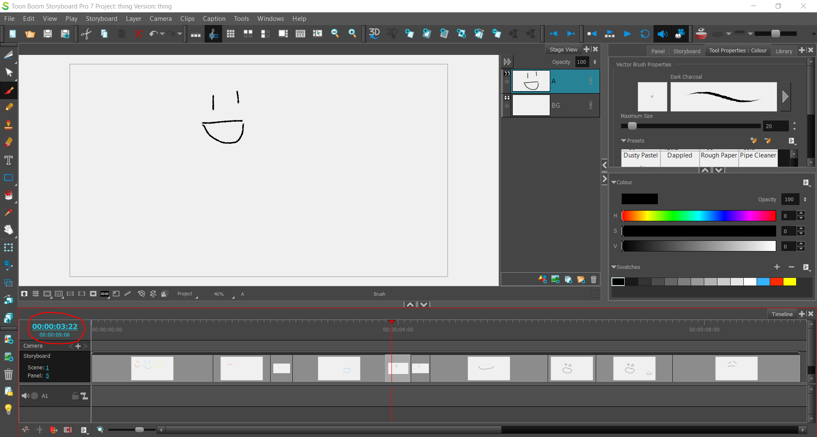
- If you want to play your storyboard to see how it looks, press this blue play button!
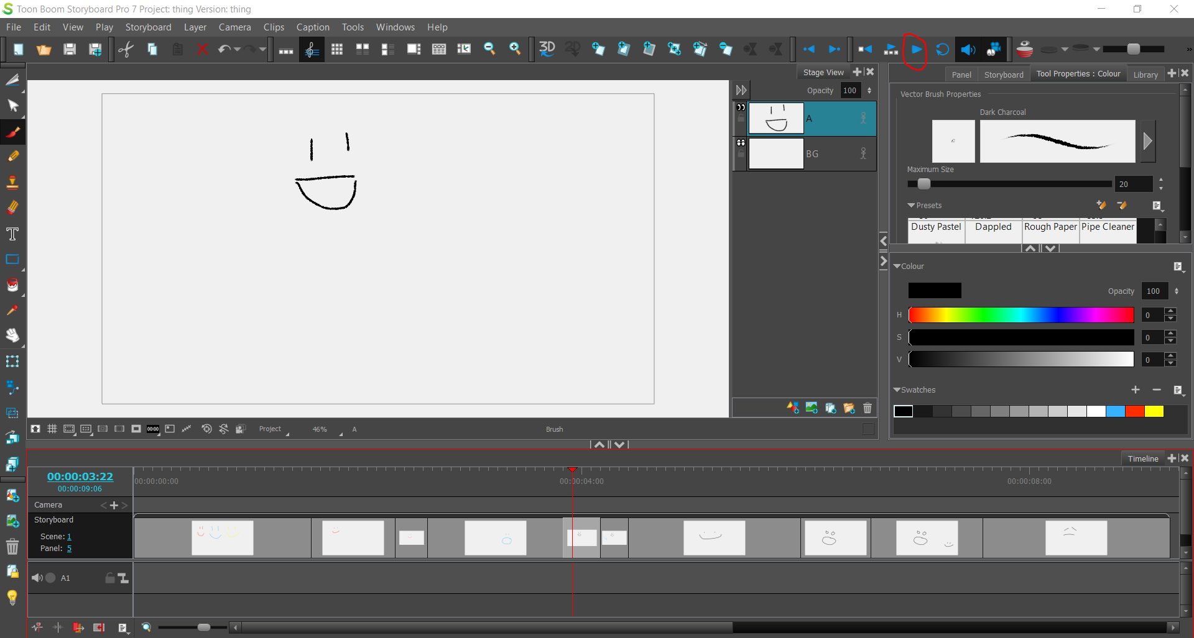

- Don’t forget to save your work as you go using this button!
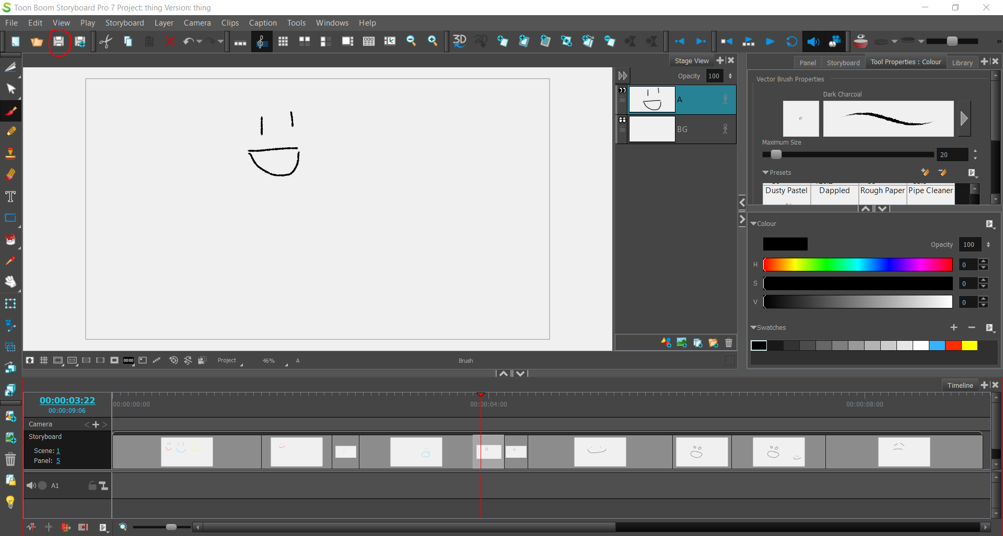

- To export your storyboard as a video, click on File, then Export, and then Movie. On this screen, all you have to worry about is picking where you want your video to be saved and the name of it! Then you click export and the program will export a video.
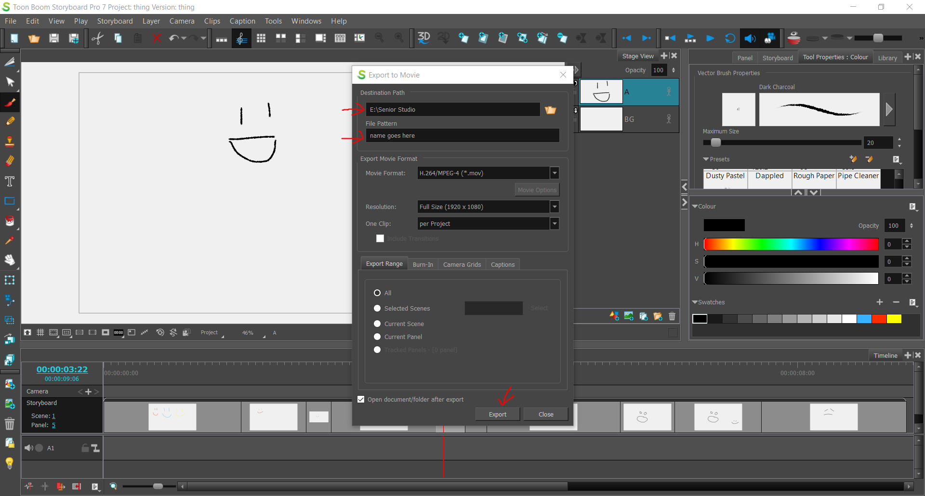

- One final note is that if you save and close your storyboard and want to return to it later, you will need to open the folder it’s in and double click on this program file to open back up your storyboard.
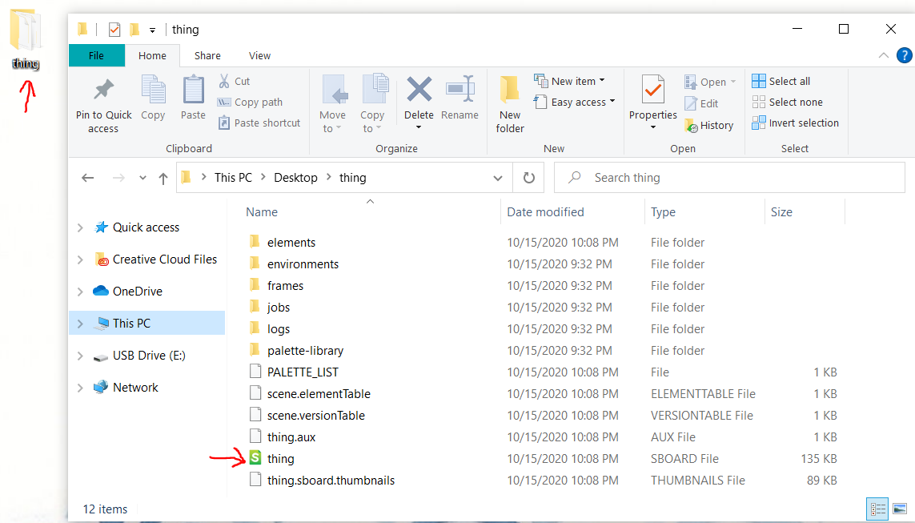
Congrats! You now know how to use the basics for ToonBoom Storyboard PRO!
Happy Storyboarding!

